THE TRAUMA TIMELINE
Jot down whatever incidents or relational dynamics from your own life, that felt highly stressful, painful, or traumatizing to you.

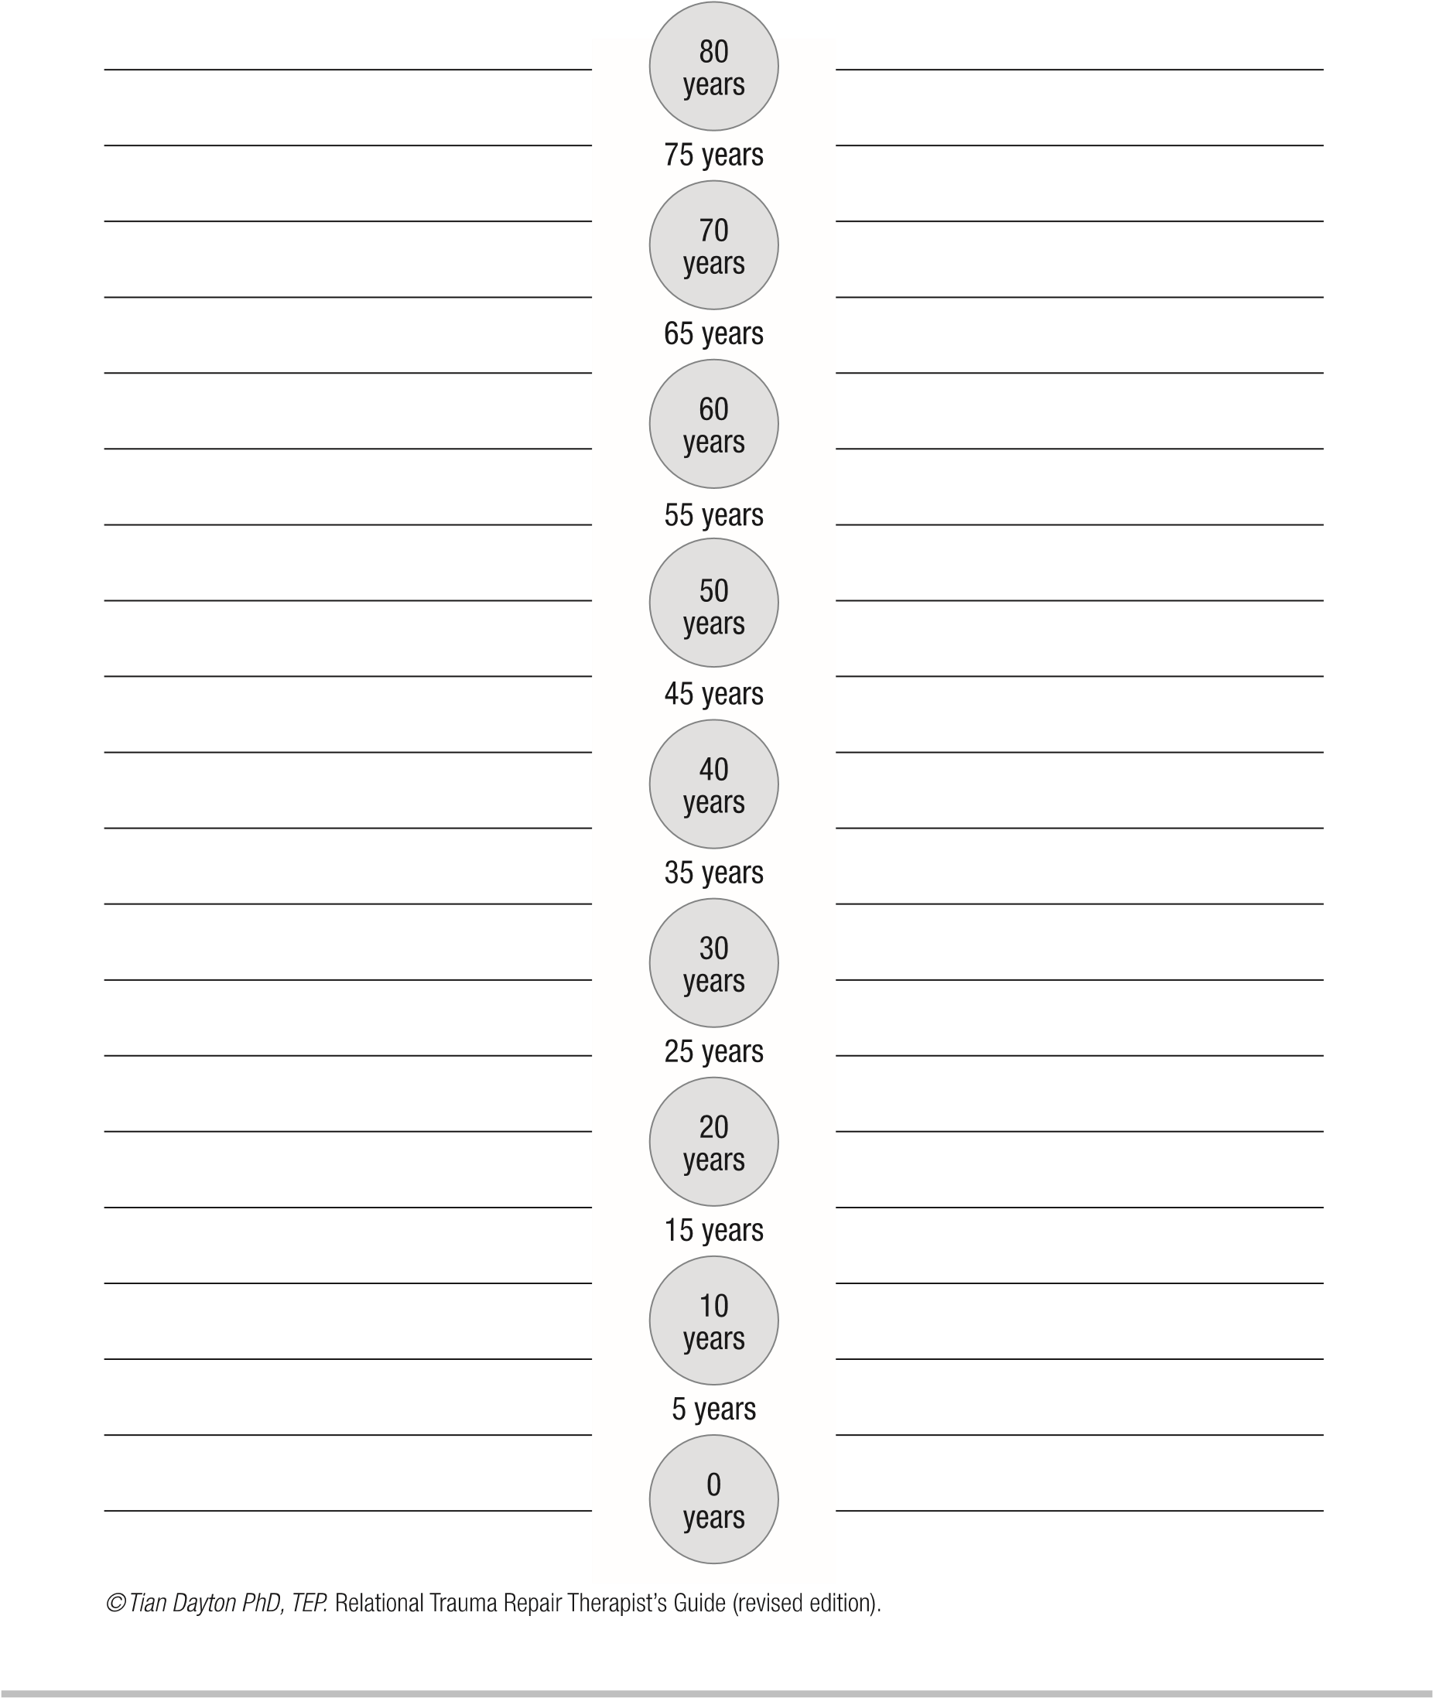

Resilience Timeline

